A report documenting the creation process of the S3 bucket, IAM role, and

Lambda function. Include any challenges encountered and how they were

resolved.

S3 bucket was created using the CLI, below are the steps included in creation of bucket

Step 1: login to aws using command: aws configure and enter access key pairs.

Step 2: create s3 bucket using command: aws s3 mb s3://gwd-lambda

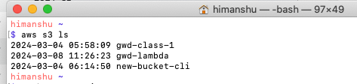

IAM role was created through Console, attached policies related to S3, cloudwatch and lambda.

New IAM role name: gwd-aws-lambda-role

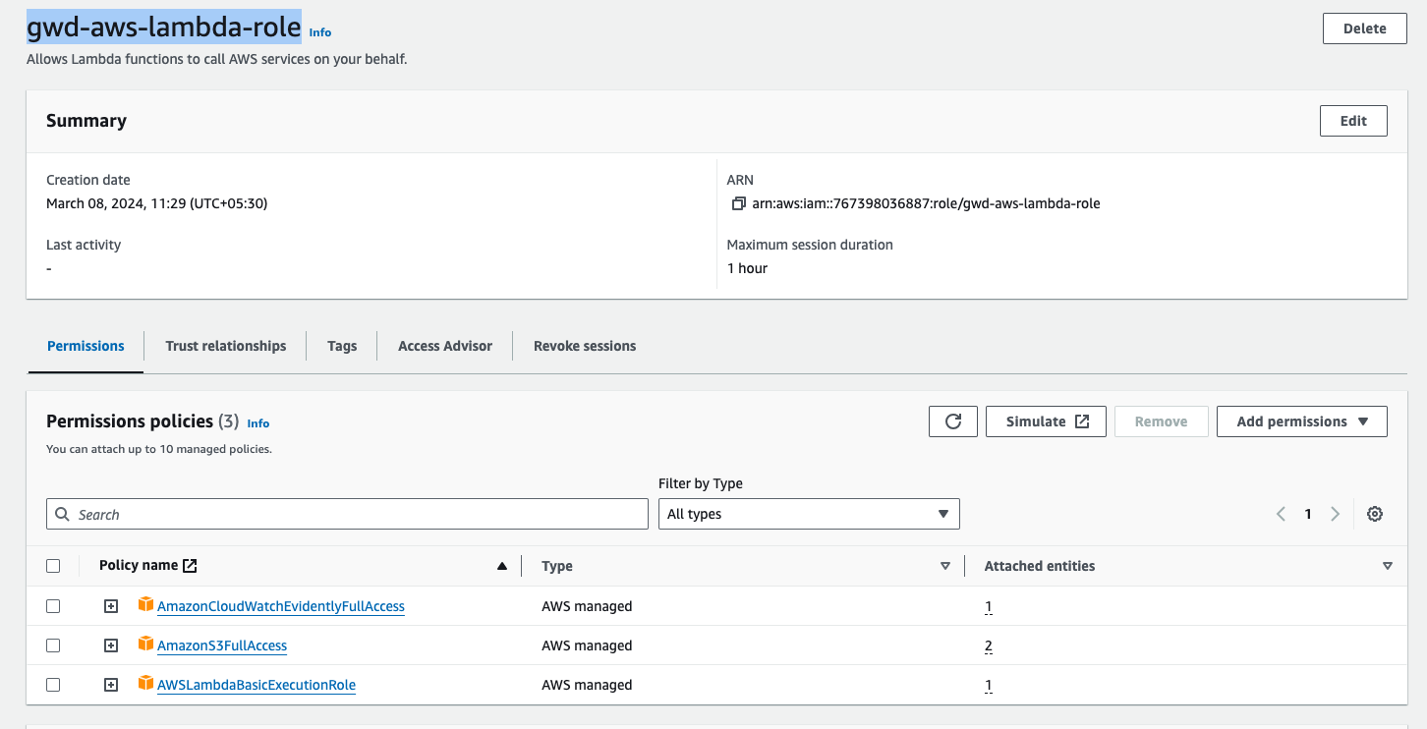

Lastly created lambda function through console as well.

Name of lambda function: **lambda-assignment-1**

Below is the screenshot of lambda function configurations:

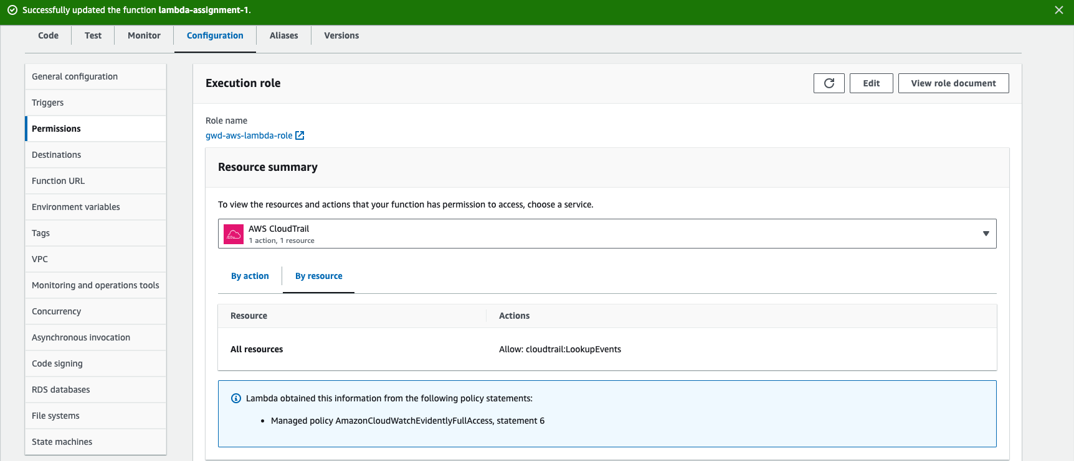

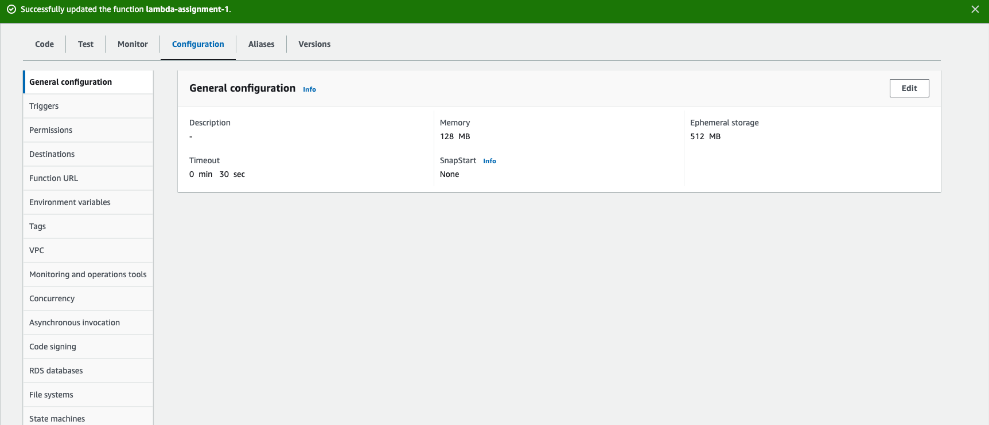

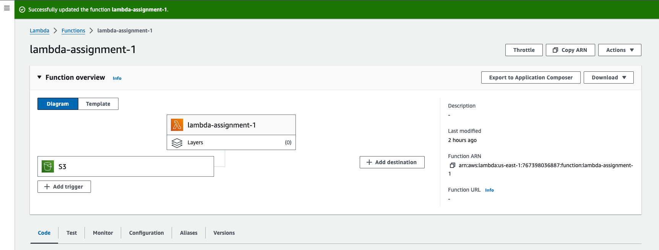

Trigger Details

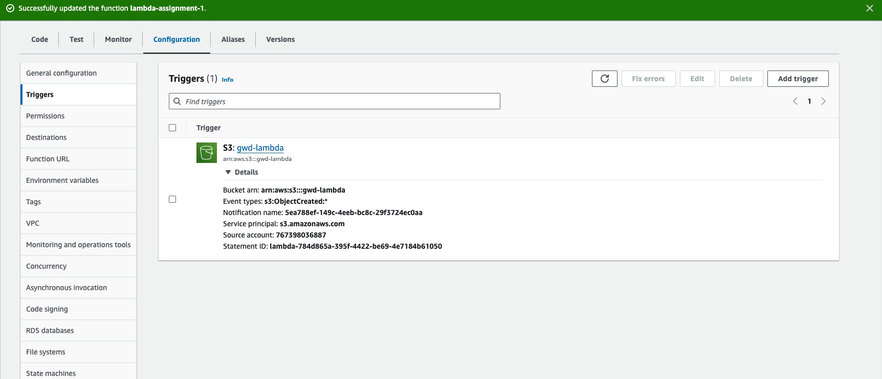

lambda_function.py

| import logging import json import boto3 import os  default_log_args = {  "level": logging.DEBUG if os.environ.get("DEBUG", False) else logging.INFO,  "format": "%(asctime)s [%(levelname)s] %(name)s - %(message)s",  "datefmt": "%d-%b-%y %H:%M",  "force": True, } logging.basicConfig(**default_log_args) log = logging.getLogger("")  def lambda_handler(event, context):   source_bucket = 'gwd-lambda'  s3 = boto3.client('s3')   response_contents = s3.list_objects_v2(Bucket = source_bucket).get('Contents')  sorted_rc = sorted(response_contents,key = lambda x:x['LastModified'],reverse=True)  current_uploaded_file = sorted_rc[0]    file_size = round(current_uploaded_file.get('Size')/1024**2,2)  if file_size > 100:  log.info(f"Uploaded file size is GREATER than 100 MB")  log.info(f"File Name: {current_uploaded_file.get('Key')}")  log.info(f"Size: {file_size}")  else:  log.info(f"Uploaded file size is SMALL than 100 MB")  log.info(f"File Name: {current_uploaded_file.get('Key')}")  log.info(f"Size of file {file_size}")   return {  'statusCode': 200,  'body': json.dumps('Lambda triggered on file upload')  } |
| --- |

Cloud watch logs:

When uploaded file size greater than 100mb:

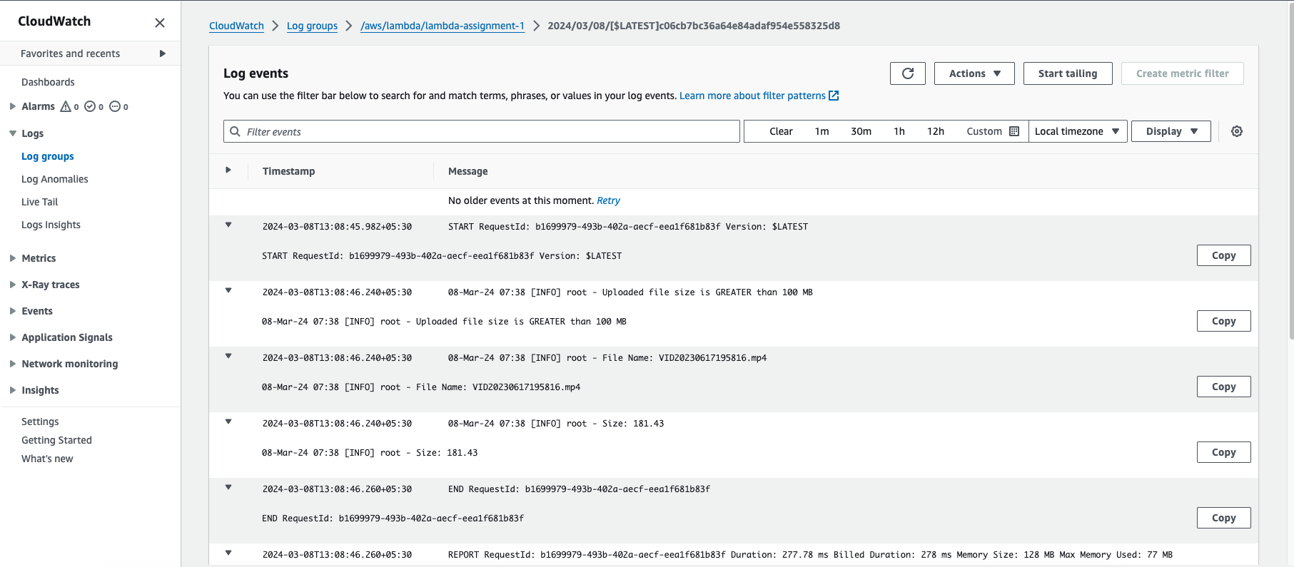

When file size is less than 100 MB:

